 | Year Prep Term 3  2024
English |  |  | Mathematics | 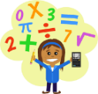 | Science | 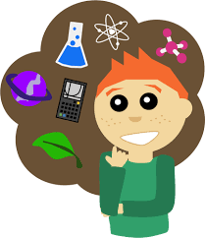 | HASS | 
Interacting With Others  - Listen to a variety of texts and retell stories  - Share thoughts about story events with others  - Create a short spoken retell of an experience  - Phonics (blending three and four sounds)  - Read a variety of decodable texts with increasing fluency  - Casey the Caterpillar (letter writing)  - Written retells of stories and experiences |  |  | Explore the following concepts:  - Count forwards to 15 from a given number  - Make a connection between number names/quantities and numerals to 15  - Count larger collections  - Compare and order numbers larger collections  - Represent practical situations for sharing, adding to and taking away from collections to at least 10  - Name, create and sort familiar shapes and giving reasoning |  | Weather Watch  - Explore how weather affects themselves and other living things  - Share observations about the weather  - Asking and responding to Science questions   |  | Features of and Caring for Special Places  Taught across Semester 2  - Explore the place they live in and belong to  - Observe and describe its features and why it is important to them  - Describe how they can care for their special place  - Draw maps and create models to show familiar places
HPE |  | 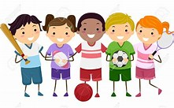 | HEALTH |  | STEAM |  | The Arts:  Dance | 
Who Wants to Play?  - Social skills for working with others  - Describe their feelings after participating in a range of active games |  |  | Looking Out For Others and I Am Safe  Taught across Semester 2  - Explore different emotions  - Practice ways to interact with others  Explore actions that keep them safe with medicines and poisons and in situations involving water and fire |  | - Identify the purposes of common digital systems  - Create simple patterns  - Create and share information using Seesaw  - Design an algorithm to assist a baby animal to find its mother. |  | Dancing Characters  In this unit students make and respond to dance by exploring characters in stories and rhymes as stimulus.
Messages from teachers |  |  | 2024 School Priorities |  |  |  | Wellbeing
  We encourage each student to bring a water bottle to school daily. They will be able to keep their water bottle in the classroom within easy reach during learning time.  Students are encouraged to bring a brain snack to class each day which will be eaten in the first session at desks while working. Something that is small and easy to eat one-handed such as cut up fruit, cheese, etc., would be ideal. |  |  | Know your Students, know your Curriculum, know your Strategies to empower critical and creative thinkers to  Grow, Achieve and Succeed as lifelong learners.  Great things through hard work |  |  |  | 5 Keys to Success  Getting Along  Organisation  Confidence  Persistence  Resilience

